

BEGUM ROKEYA UNIVERSITY, RANGPUR

Assignment On
Course Code: STAT2205
Course Title: Programming With R and Python

Submitted By: | Submitted To:
Name: shamsuzzaman  ID: 12310004  Reg: 000018836  Year: 2nd  Session: 2023-24  Department Of Statistics  Begum Rokeya University, Rangpur | dr. md. siddikur rahman  associate professor  Department Of Statistics  Begum Rokeya University, Rangpur
Submission Date: 20 May, 2026
Question:1 What do coach ticket price look like? What are the high and low values? What would be considered the average? Does $500 seem like a good price for a coach ticket?
Solution:
R Code:
airline <- read.csv("C:/Users/KHAN GADGET/Documents/Siddik Sir/STAT 2205/Sir File/flight_data.csv")
# Random sample using your ID
set.seed(12310047)
flight <- airline[sample(nrow(airline), 10047), ]
# Highest coach ticket price
max(flight$coach_price, na.rm = TRUE)
# Lowest coach ticket price
min(flight$coach_price, na.rm = TRUE)
# Average coach ticket price
mean(flight$coach_price, na.rm = TRUE)
# Median coach ticket price
median(flight$coach_price, na.rm = TRUE)
# Summary statistics
summary(flight$coach_price)
# Standard deviation
sd(flight$coach_price, na.rm = TRUE)
# Histogram of coach ticket prices
hist(flight$coach_price,
main = "Distribution of Coach Ticket Prices",
xlab = "Coach Ticket Price",
col = "skyblue",
border = "black")

# Boxplot of coach ticket prices
boxplot(flight$coach_price,
main = "Boxplot of Coach Ticket Prices",
ylab = "Coach Ticket Price",
col = "lightgreen")
# Check if $500 seems reasonable
avg_price<- mean(flight$coach_price, na.rm = TRUE)
avg_price
500
Python Code:
# Coach Ticket Price Analysis
# Random sample using ID
flight = airline.sample(n=10047, random_state=12310047)
# Highest coach ticket price
max_price = flight["coach_price"].max()
# Lowest coach ticket price
min_price = flight["coach_price"].min()
# Average coach ticket price
mean_price = flight["coach_price"].mean()
# Median coach ticket price
median_price = flight["coach_price"].median()
# Standard deviation
std_price = flight["coach_price"].std()
# Display results
print("Highest Coach Ticket Price =", max_price)
print("Lowest Coach Ticket Price =", min_price)
print("Average Coach Ticket Price =", mean_price)
print("Median Coach Ticket Price =", median_price)
print("Standard Deviation =", std_price)
# Summary statistics
print("\nSummary Statistics:")
print(flight["coach_price"].describe())
# Histogram
plt.figure(figsize=(8,5))
plt.hist(
flight["coach_price"],
bins=8,
color="skyblue",
edgecolor="black"
)
plt.title("Distribution of Coach Ticket Prices")
plt.xlabel("Coach Ticket Price")
plt.ylabel("Frequency")
plt.show()
# Boxplot
plt.figure(figsize=(8,5))
plt.boxplot(
flight["coach_price"],
patch_artist=True,
boxprops=dict(facecolor="lightgreen")
)
plt.title("Boxplot of Coach Ticket Prices")
plt.ylabel("Coach Ticket Price")
plt.show()
# Is $500 a Good Price?
if mean_price < 500:
print("\n$500 is relatively expensive compared to the average coach ticket price.")
else:
print("\n$500 is a reasonable coach ticket price.")

Output:
Coach Ticket Price Analysis:
- Highest Coach Ticket Price: $560.795$
- Lowest Coach Ticket Price: $44.415$
- Average (Mean) Coach Ticket Price: $\overset{ˉ}{x}=\frac{∑x_{i}}{n}$ $=375.5538$
- Median Coach Ticket Price: $380.55$
Statistic | Value
Minimum | 44.41
1st Quartile | 329.87
Median | 380.55
Mean | 375.55
3rd Quartile | 426.01
Maximum | 560.79
- Summary Statistics:
- Standard Deviation: $68.01488$

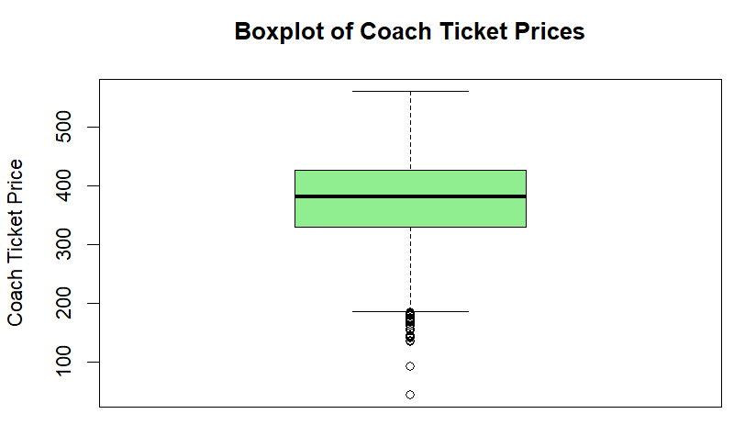
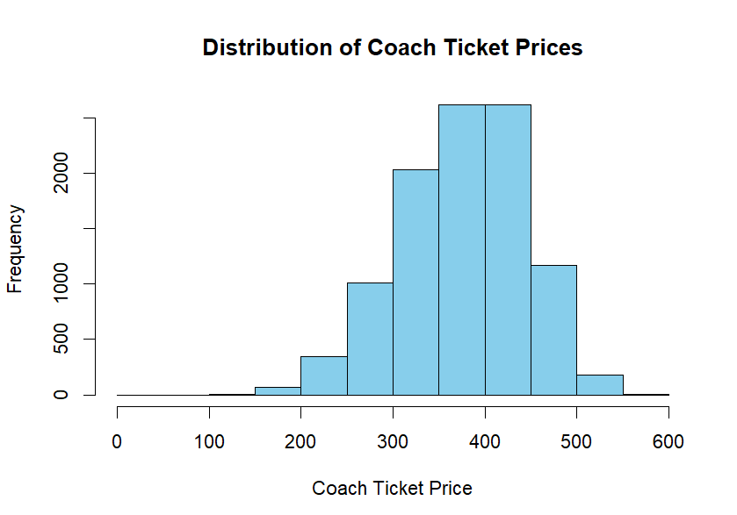

Interpretation: The histogram shows that most coach ticket prices are concentrated between approximately $300 and $450, with the distribution appearing fairly bell-shaped. The average coach ticket price is around the mid-$300 range, while a few low-price outliers are visible in the boxplot.
The boxplot also indicates some unusually low ticket prices, but no extreme high-price outliers. Since $500 is higher than the average ticket price, it may be considered relatively expensive for a coach ticket.

Question:2 What are the high, low, average prices for 8-hour-long flight? Does a $500 ticket seem more reasonable than before?
Solution:
R Code
# Flights with approximately 8-hour duration
flight_8hr <- subset(flight, hours == 8)
# Highest price for 8-hour flights
max(flight_8hr$coach_price, na.rm = TRUE)
# Lowest price for 8-hour flights
min(flight_8hr$coach_price, na.rm = TRUE)
# Average price for 8-hour flights
mean(flight_8hr$coach_price, na.rm = TRUE)
# Median price
median(flight_8hr$coach_price, na.rm = TRUE)
# Summary statistics
summary(flight_8hr$coach_price)
# Standard deviation
sd(flight_8hr$coach_price, na.rm = TRUE)
# Histogram
hist(flight_8hr$coach_price,
main = "Distribution of 8-Hour Flight Prices",
xlab = "Coach Ticket Price",
col = "skyblue",
border = "black")
# Boxplot
boxplot(flight_8hr$coach_price,
main = "Boxplot of 8-Hour Flight Prices",
ylab = "Coach Ticket Price",
col = "orange")
Python Code:
#Select flight around 8 Hours
eighthour_flight=sample_airline[(sample_airline["hours"]>=7.5)
& (sample_airline["hours"]<=8.5)]
print(eighthour_flight)
# High price
high_price=eighthour_flight["coach_price"].max()
print(high_price)
#Low Price
low_price=eighthour_flight["coach_price"].min()
print(low_price)
#Average price
avg_price=eighthour_flight["coach_price"].mean()
print(avg_price)
#Median price
median_price=eighthour_flight["coach_price"].median()
print(median_price)

Output:
8-Hour Flight Price Analysis:
- Highest Coach Ticket Price (8-hour flights): $558.295$
- Lowest Coach Ticket Price (8-hour flights): $278.28$
- Average (Mean) Coach Ticket Price: $\overset{ˉ}{x}=\frac{∑x_{i}}{n}$ $=$ $429.4462$
- Median Coach Ticket Price: $439.485$
Statistic | Value
Minimum | 278.3
1st Quartile | 387.9
Median | 439.5
Mean | 429.4
3rd Quartile | 475.2
Maximum | 558.3
- Summary Statistics:
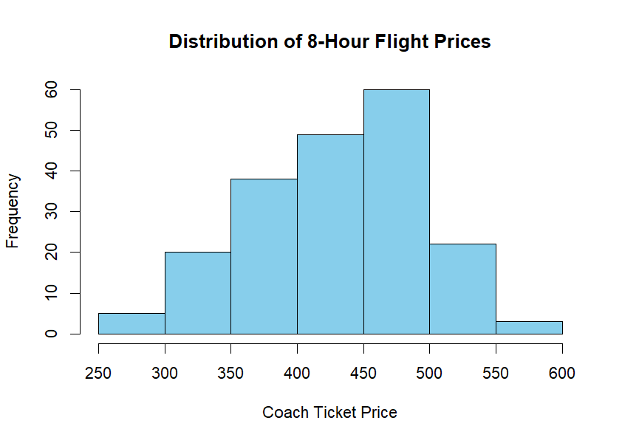
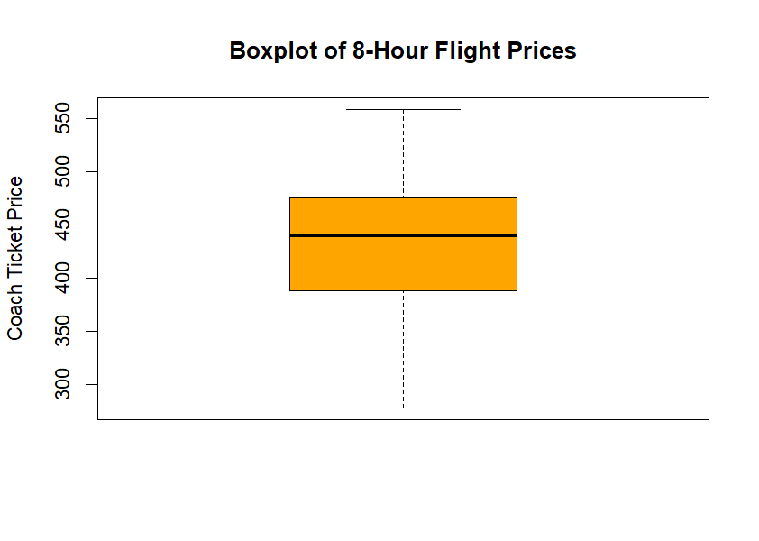
- Standard Deviation: $62.86204$

Interpretation: Most 8-hour flight ticket prices are concentrated between approximately $380 and $500. The distribution appears moderately symmetric with no extreme outliers in the boxplot.
The average coach ticket price for 8-hour flights is about $429.45, indicating that longer flights generally have relatively higher ticket prices.
Question:3 How are flight delay times distributed? How often there significant delays that affect your ability to correctly schedule connecting flights? What kinds of delays are typical?
Solution:
R Code:
# Summary statistics for delays
summary(flight$delay)
# Mean delay
mean(flight$delay, na.rm = TRUE)
# Median delay
median(flight$delay, na.rm = TRUE)
# Standard deviation
sd(flight$delay, na.rm = TRUE)
# Maximum delay
max(flight$delay, na.rm = TRUE)
# Minimum delay
min(flight$delay, na.rm = TRUE)
# Histogram of delays
hist(flight$delay,
main = "Distribution of Flight Delays",
xlab = "Delay Time (Minutes)",
col = "skyblue",
border = "black")
# Boxplot of delays
boxplot(flight$delay,
main = "Boxplot of Flight Delays",
ylab = "Delay Time (Minutes)",
col = "orange")
# Number of significant delays (more than 60 minutes)
sum(flight$delay > 60, na.rm = TRUE)
# Percentage of significant delays
mean(flight$delay > 60, na.rm = TRUE) * 100

Python Code:
#Distribution of flight delay
mean_delays=sample_airline["delay"].mean()
print(mean_delays)
from scipy.stats import skew,kurtosis
print(skew(sample_airline["delay"]))
print(kurtosis(sample_airline["delay"]))
#Histogram
import matplotlib.pyplot as plt
plt.hist(sample_airline["delay"],
bins=150,
color="seagreen",
edgecolor="black")
plt.xlim(0,200)
plt.title("Distribution of Flight Delay")
plt.xlabel("Delay")
plt.ylabel("Frequency")
plt.show()

Output:
- Highest Delay: 1530
- Lowest Delay: 0
- Average (Mean) Delay: $\overset{ˉ}{x}=\frac{∑x_{i}}{n}=12.83746$
- Median Delay: 10
Statistic | Value
Minimum | 0.00
1st Quartile | 8.00
Median | 10.00
Mean | 12.84
3rd Quartile | 12.00
Maximum | 1530.00
- Summary Statistics:

- Standard Deviation: 37.18498
- Number of Significant Delays (> 60 minutes):
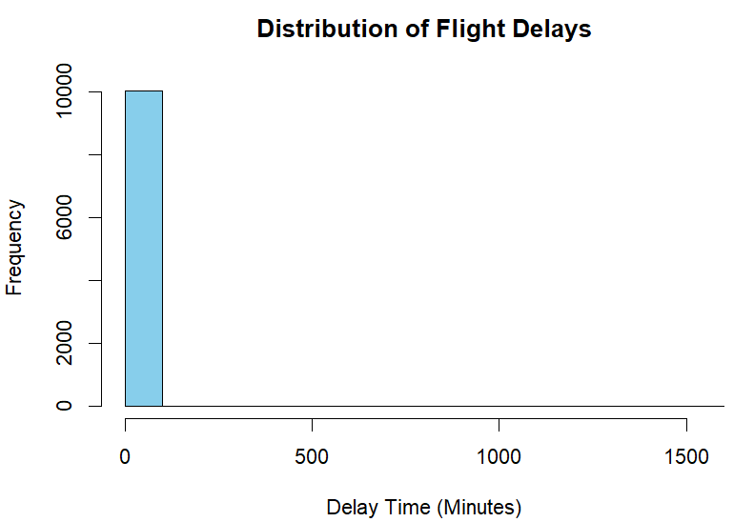
- Percentage of Significant Delays: 0.0597%
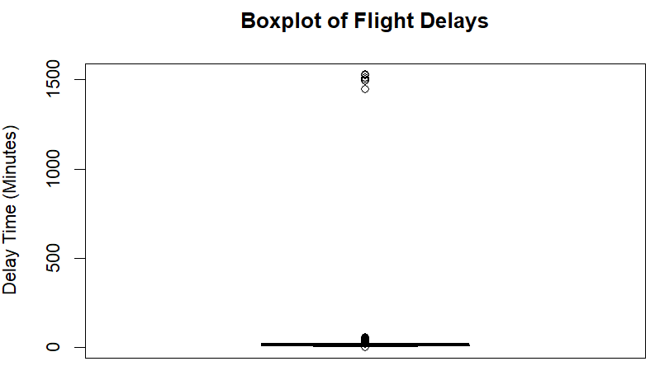

Interpretation: Most flights experienced short delays, with an average delay of about 12.84 minutes. However, a few extreme delays were present, as the maximum delay reached 1530 minutes.

Question:4 How does coach price correlate with flight distance,number of passengers, delay and flight duration?
Solution:
R Code:
# Select numeric variables
variables <- flight[, c("coach_price",
"miles",
"passengers",
"delay",
"hours")]
# Correlation matrix
cor(variables, use = "complete.obs")
# Scatter plots
# Coach price vs miles
plot(flight$miles,
flight$coach_price,
main = "Coach Price vs Flight Distance",
xlab = "Miles",
ylab = "Coach Price",
col = "blue",
pch = 19)
# Coach price vs passengers
plot(flight$passengers,
flight$coach_price,
main = "Coach Price vs Number of Passengers",
xlab = "Passengers",
ylab = "Coach Price",
col = "green",
pch = 19)
# Coach price vs delay
plot(flight$delay,
flight$coach_price,
main = "Coach Price vs Delay",
xlab = "Delay (Minutes)",
ylab = "Coach Price",
col = "red",
pch = 19)
# Coach price vs hours
plot(flight$hours,
flight$coach_price,
main = "Coach Price vs Flight Duration",
xlab = "Hours",
ylab = "Coach Price",
col = "purple",
pch = 19)

Python Code:
#Correlation between coach price and miles
corr_price_mile=sample_airline["coach_price"].corr(sample_airline["miles"])
print("Correlation_price_miles=",corr_price_mile)
#Correlation between coach price and passengers
corr_price_passengers=sample_airline["coach_price"].corr(sample_airline["passengers"])
print("Correlation_price-passengers=",corr_price_passengers)
#Correlation between coach price and flight duration
corr_price_hours=sample_airline["coach_price"].corr(sample_airline["hours"])
print("Correlation-price-duartion=",corr_price_hours)

Output:
Correlation Matrix:
Variables | Coach Price | Miles | Passengers | Delay | Hours
Coach Price | 1.0000 | 0.3315 | 0.1758 | 0.0012 | 0.3255
Miles | 0.3315 | 1.0000 | -0.0064 | 0.0052 | 0.9849
Passengers | 0.1758 | -0.0064 | 1.0000 | -0.0157 | -0.0070
Delay | 0.0012 | 0.0052 | -0.0157 | 1.0000 | 0.0093
Hours | 0.3255 | 0.9849 | -0.0070 | 0.0093 | 1.0000
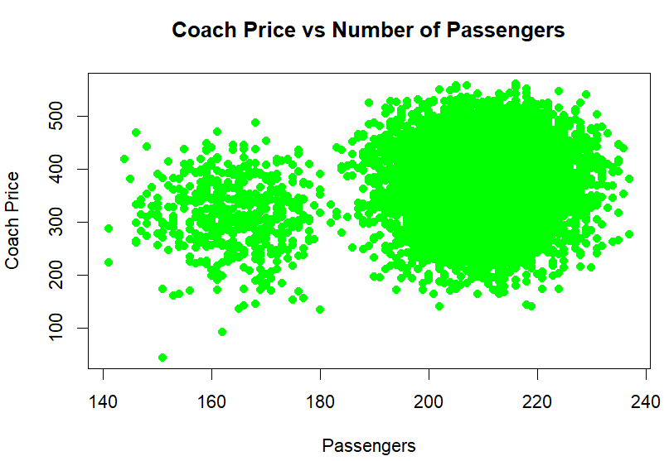
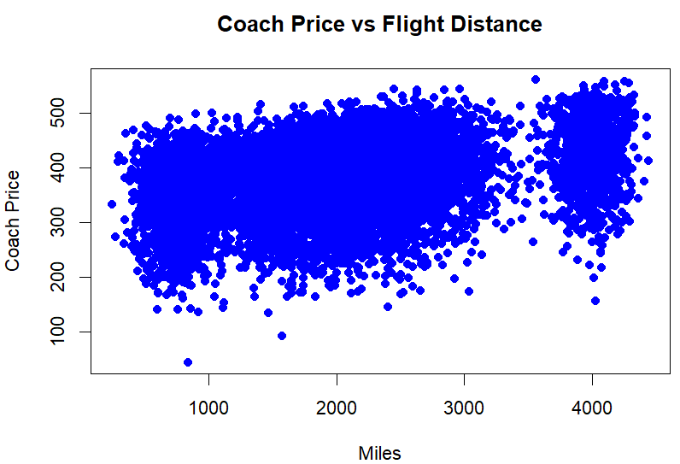

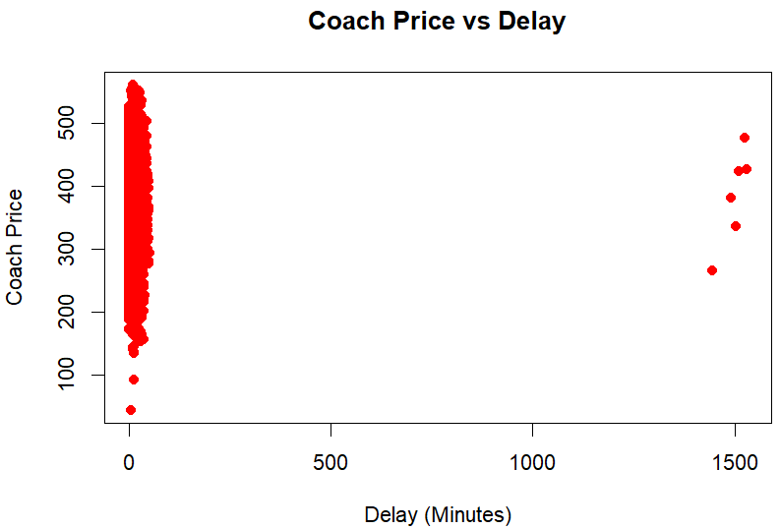
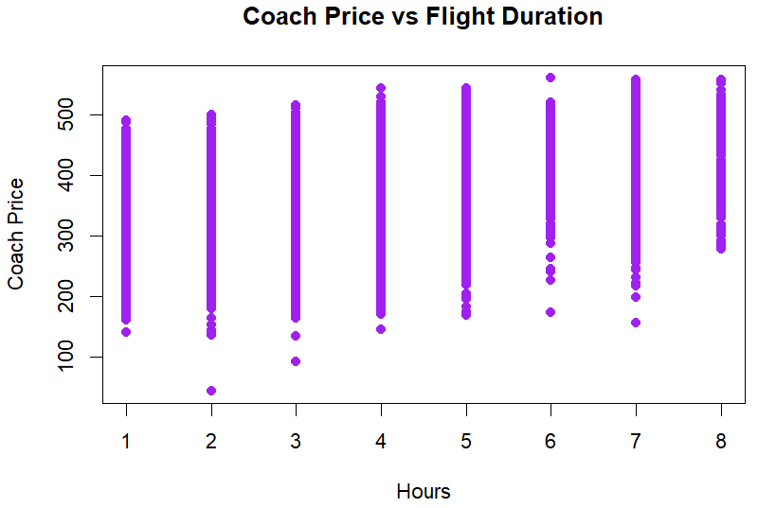

Interpretation:
• Coach Price vs Miles:
There is a moderate positive correlation ($r=0.3315$) between coach ticket price and flight distance. This indicates that longer flights generally have higher ticket prices.
• Coach Price vs Passengers:
A weak positive correlation ($r=0.1758$) exists between coach price and number of passengers. Passenger count has only a small influence on ticket prices.
• Coach Price vs Delay:
The correlation between coach price and delay is nearly zero ($r=0.0012$). This suggests that flight delays do not significantly affect coach ticket prices.
• Coach Price vs Hours:
There is a moderate positive correlation ($r=0.3255$) between coach price and flight duration. Flights with longer durations tend to have higher coach ticket prices.
• Miles vs Hours:
Miles and hours have a very strong positive correlation ($r=0.9849$), indicating that longer distances are strongly associated with longer flight durations.

Question:5 What is the relationship between coach and first-class prices? Do flight with higher coach prices always have higher first-class prices as well?
Solution:
R Code:
# Correlation between coach and first-class prices
cor(flight$coach_price,
flight$firstclass_price,
use = "complete.obs")
# Scatter plot
plot(flight$coach_price,
flight$firstclass_price,
main = "Coach Price vs First-Class Price",
xlab = "Coach Ticket Price",
ylab = "First-Class Ticket Price",
col = "blue",
pch = 19)
# Linear regression model
model_fc <- lm(firstclass_price ~ coach_price, data = flight)
# Regression summary
summary(model_fc)
# Add regression line
abline(model_fc, col = "red", lwd = 2)

Python Code:
#Correlation between coach price and first-class-price
r=sample_airline["coach_price"].corr(sample_airline["firstclass_price"])
print("r=",r)
#Scatter plot
import matplotlib.pyplot as plt
plt.scatter(sample_airline["coach_price"],
sample_airline["firstclass_price"],
color="darkgreen")
plt.title("Coach Price VS First-class-price")
plt.xlabel("Coach Price")
plt.ylabel("First-class-price")
plt.show()
Output:
Regression Equation: $\hat{Y}=766.35723+1.82888X$
where,
- $\hat{Y}$= Predicted First-Class Ticket Price
- $X$= Coach Ticket Price

Correlation Between Coach and First-Class Prices:
Measure | Value
Correlation Coefficient ((r)) | 0.7634
Intercept ((\beta_0)) | 766.35723
Slope ((\beta_1)) | 1.82888
Multiple (R^2) | 0.5828
Adjusted (R^2) | 0.5828
Residual Standard Error | 105.2
p-value | < 2.2e-16
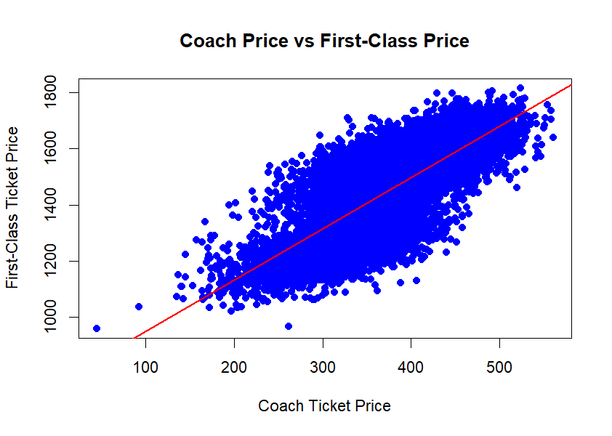
Interpretation: There is a strong positive correlation ($r=0.7634$) between coach ticket prices and first-class ticket prices. This indicates that flights with higher coach prices generally also have higher first-class prices.
The regression model suggests that for every $1 increase in coach ticket price, the first-class ticket price increases by approximately $1.83 on average. The $R^{2}=0.5828$indicates that about 58.28% of the variation in first-class prices is explained by coach ticket prices.

Question:6 What is the relationship between coach prices and in-flight features:
in-flight meal, in-flight entertainment,and in flight WiFi? Which features are
associated with the highest increase in price?

Solution:
R Code:
# Average coach price by meal availability
aggregate(coach_price ~ inflight_meal,
data = flight,
mean)

# Average coach price by entertainment availability
aggregate(coach_price ~ inflight_entertainment,
data = flight,
mean)
# Average coach price by WiFi availability
aggregate(coach_price ~ inflight_wifi,
data = flight,
mean)
# Boxplot for meal
boxplot(coach_price ~ inflight_meal,
data = flight,
main = "Coach Price by In-Flight Meal",
xlab = "Meal Available",
ylab = "Coach Price",
col = "skyblue")
# Boxplot for entertainment
boxplot(coach_price ~ inflight_entertainment,
data = flight,
main = "Coach Price by In-Flight Entertainment",
xlab = "Entertainment Available",
ylab = "Coach Price",
col = "lightgreen")
# Boxplot for WiFi
boxplot(coach_price ~ inflight_wifi,
data = flight,
main = "Coach Price by In-Flight WiFi",
xlab = "WiFi Available",
ylab = "Coach Price",
col = "orange")
Python Code:
#Coach price and in-flight meal
aggregate(sample_airline$coach_price,by=
list(sample_airline$inflight_meal),
mean)
#Coach price and in-flight entertainment
aggregate(sample_airline$coach_price,
by=
list(sample_airline$inflight_entertainment),
mean)
#Coach price and in-flight WiFi
aggregate(sample_airline$coach_price,
by=
list(sample_airline$inflight_wifi),
mean)
#Boxplot(Inflight WiFi)
ggplot(sample_airline,aes(x=inflight_wifi,
y=coach_price,
fill=
inflight_wifi))+
geom_boxplot(fill="brown",col="darkgreen")+
labs(title="Inflight WiFi vs Coach Price")
#Boxplot(Infight meal)
ggplot(sample_airline,aes(x=inflight_meal,
y=coach_price,
fill=
inflight_meal))+
geom_boxplot(fill="seagreen",col='black')+
labs(title="Inflight meal vs Coach Price")
Output:
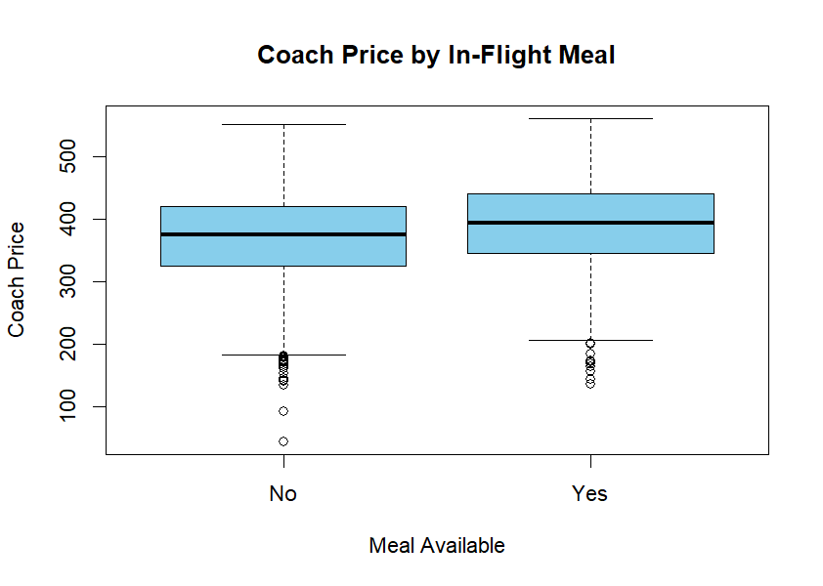
Average Coach Price by In-Flight Services:
Service | Availability | Average Coach Price
In-Flight Meal | No | 369.5032
In-Flight Meal | Yes | 389.8479
In-Flight Entertainment | No | 318.2630
In-Flight Entertainment | Yes | 389.8462
In-Flight WiFi | No | 309.9331
In-Flight WiFi | Yes | 382.6463
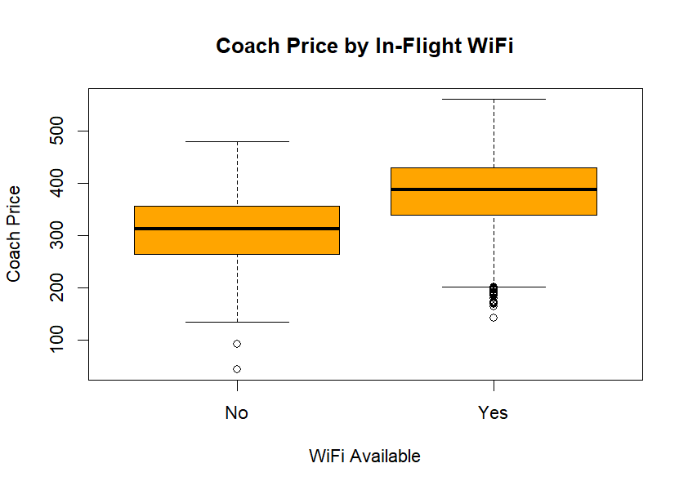
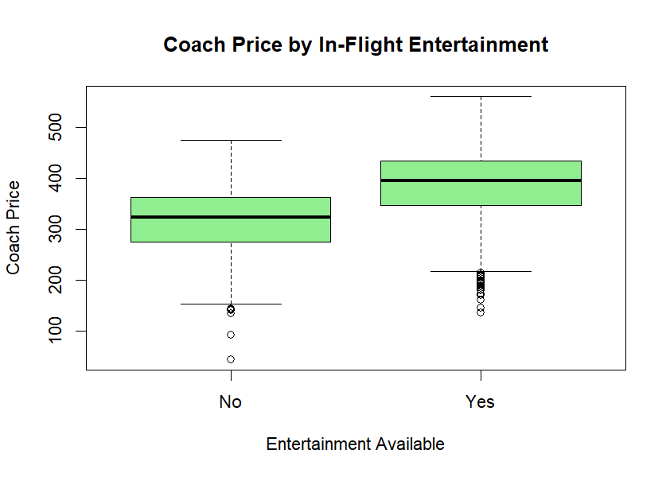

Interpretation:
- In-Flight Meal:
Flights that provide meals have a slightly higher average coach ticket price compared to flights without meals. This suggests that meal service may increase ticket cost.
- In-Flight Entertainment:
Flights with entertainment systems have noticeably higher coach ticket prices than flights without entertainment. Entertainment availability appears to have a strong influence on ticket pricing.
- In-Flight WiFi:
Flights offering complimentary WiFi also have higher average coach ticket prices. This indicates that additional onboard services are associated with more expensive tickets.

Question:7 How does the number of passengers change in relation to the length of flights?
Solution:
R Code:
# Correlation between passengers and flight duration
cor(flight$passengers,
flight$hours,
use = "complete.obs")
# Scatter plot
plot(flight$hours,
flight$passengers,
main = "Passengers vs Flight Duration",
xlab = "Flight Duration (Hours)",
ylab = "Number of Passengers",
col = "blue",
pch = 19)
# Linear regression model
model_pass <- lm(passengers ~ hours, data = flight)
# Regression summary
summary(model_pass)
# Add regression line
abline(model_pass, col = "red", lwd = 2)
# Average passengers by flight duration
aggregate(passengers ~ hours,
data = flight,
mean)
Python Code:
#Correlation between passengers and flight hour
r=sample_airline["passengers"].corr(sample_airline["hours"])
print("r=",r)
#Scatter plot
import matplotlib.pyplot as plt
plt.scatter(sample_airline["passengers"],
sample_airline["hours"],
color="purple")
plt.title("Scatterlot: Passengers VS Flight Hours")
plt.xlabel("Passengers")
plt.ylabel("Hours")
plt.show()

Output:
Correlation Between Passengers and Flight Duration:
Measure | Value
Correlation Coefficient ((r)) | -0.00699
Intercept ((\beta_0)) | 207.81490
Slope ((\beta_1)) | -0.05251
Multiple (R^2) | 0.00004892
Adjusted (R^2) | -0.00005063
Residual Standard Error | 12.95
p-value | 0.4833
Regression Equation: $\hat{Y}=207.81490-0.05251X$
where,
- $\hat{Y}$= Predicted Number of Passengers
- $X$= Flight Duration (Hours)
Average Passengers by Flight Duration:
Hours | Average Passengers
1 | 207.7765
2 | 208.0554
3 | 207.5442
4 | 207.6073
5 | 207.1422
6 | 207.3780
7 | 207.5478
8 | 208.6954
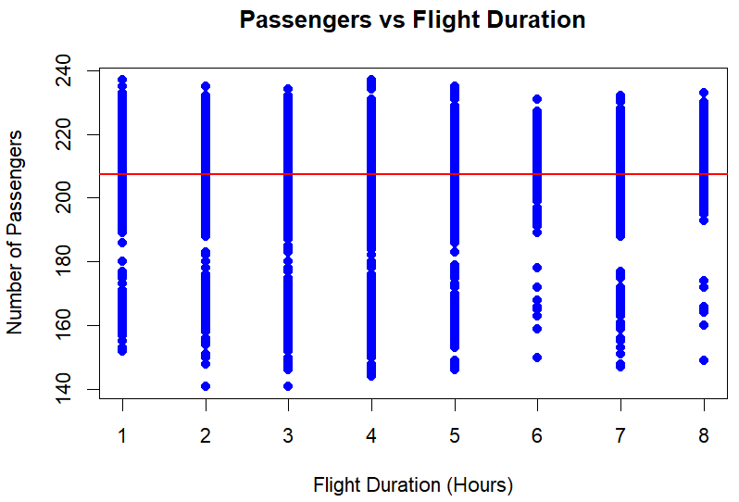
Interpretation: The correlation between flight duration and number of passengers is extremely weak and slightly negative ($r=-0.00699$). This indicates that flight duration has almost no relationship with passenger count.
The regression model also shows a very low $R^{2}$value, meaning flight duration explains almost none of the variation in passenger numbers. The average number of passengers remains nearly constant across all flight durations.

Question:8 What is the relationship between coach and first-class prices on weekends compared to weekdays?
Solution:
R Code:
# Average prices by weekend
aggregate(cbind(coach_price, firstclass_price) ~ weekend,
data = flight,
mean)
# Boxplot for coach prices
boxplot(coach_price ~ weekend,
data = flight,
main = "Coach Prices on Weekends vs Weekdays",
xlab = "Weekend",
ylab = "Coach Price",
col = "skyblue")
# Boxplot for first-class prices
boxplot(firstclass_price ~ weekend,
data = flight,
main = "First-Class Prices on Weekends vs Weekdays",
xlab = "Weekend",
ylab = "First-Class Price",
col = "orange")
# Correlation on weekdays
weekday_data <- subset(flight, weekend == "No")
cor(weekday_data$coach_price,
weekday_data$firstclass_price,
use = "complete.obs")

# Correlation on weekends
weekend_data <- subset(flight, weekend == "Yes")
cor(weekend_data$coach_price,
weekend_data$firstclass_price,
use = "complete.obs")

Python Code:
#Weekend flights
weekend_flights=sample_airline[sample_airline["weekend"]=="Yes"]

#Correlation for weekend flights
corr_weekend=weekend_flights["coach_price"].corr(weekend_flights["firstclass_price"])
print("Correlation for weekend flight:",corr_weekend)

#Weekdays flights
weekdays_flights=sample_airline[sample_airline["weekend"]=="No"]

#Correlation for weekdays flights
corr_weekdays=weekdays_flights["coach_price"].corr(weekdays_flights["firstclass_price"])
print("Correlation for weekdays",corr_weekdays)

#Scatter plot weekend
import matplotlib.pyplot as plt
plt.scatter(weekend_flights["coach_price"],
weekend_flights["firstclass_price"],
alpha=0.5,
label="Weekend")
plt.scatter(weekdays_flights["coach_price"],
weekdays_flights["firstclass_price"],
alpha=0.5,
label="Weekdays")
plt.title("Coach Price And First Class Ticket Price on Weekend and Weekdays")
plt.xlabel("Coach Price")
plt.ylabel("First Class Price")
plt.legend()
plt.show()
Output:
Average Ticket Prices on Weekends vs Weekdays:
Weekend | Average Coach Price | Average First-Class Price
No | 320.2735 | 1258.031
Yes | 405.5754 | 1559.190
Category | Correlation ((r))
Weekdays | 0.6226
Weekends | 0.6244
Correlation Between Coach and First-Class Prices:

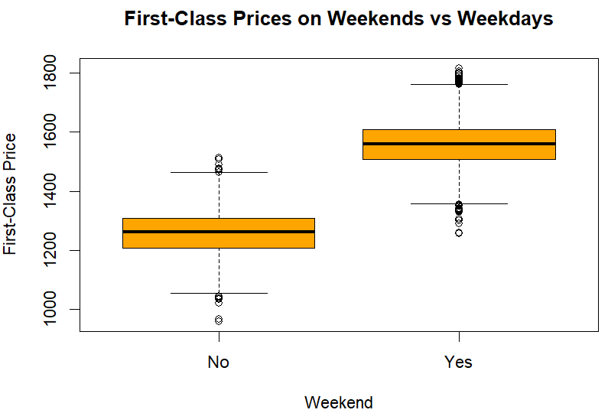
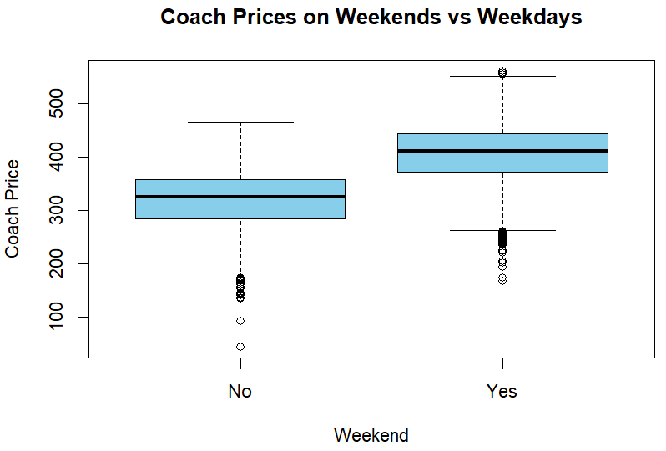

Interpretation: Coach and first-class ticket prices are higher on weekends compared to
weekdays. This suggests that demand for flights increases during weekends, leading to higher
ticket prices.
The correlation between coach and first-class prices is moderately positive on both weekdays
and weekends. This indicates that when coach ticket prices increase, first-class ticket prices
also tend to increase similarly.

Question:9 How do coach price differ for redeys and non-redeys on each day of week?
Solution:
R Code:
# Average coach prices by day and redeye status
aggregate(coach_price ~ day_of_week + redeye,
data = flight,
mean)
# Boxplot of coach prices by redeye
boxplot(coach_price ~ redeye,
data = flight,
main = "Coach Prices for Redeye vs Non-Redeye Flights",
xlab = "Redeye Flight",
ylab = "Coach Price",
col = c("skyblue", "orange"))
# Interaction plot
interaction.plot(flight$day_of_week,
flight$redeye,
flight$coach_price,
col = c("blue", "red"),
lwd = 2,
xlab = "Day of Week",
ylab = "Average Coach Price",
trace.label = "Redeye")
Python Code:
#Average coach price by redeye and day of week
price_changes=sample_airline.groupby(["redeye","day_of_week"])[
"coach_price"].mean()
print("Average Coach Price:",price_changes)
#Seperate redeye and non-redeye data
redeye_yes=sample_airline[sample_airline["redeye"]=="Yes"]
redeye_no=sample_airline[sample_airline["redeye"]=="No"]
#Scatter plot
import matplotlib.pyplot as plt
plt.figure(figsize=(10,6))
plt.scatter(redeye_yes["day_of_week"],
redeye_yes["coach_price"],
alpha=0.5,
label="Redeye")
plt.scatter(redeye_no["day_of_week"],
redeye_no["coach_price"],
alpha=0.5,
label="Non-Redeye")
plt.title("Coach price by day of week and Redeye")
plt.xlabel("Day of Week")
plt.ylabel("Coach Price")
plt.legend()
plt.show()

Output:
Average Coach Prices by Day and Redeye Status:
Day of Week | Redeye | Average Coach Price
Friday | No | 404.7464
Monday | No | 321.8781
Saturday | No | 415.9845
Sunday | No | 403.8397
Thursday | No | 324.4540
Tuesday | No | 322.3483
Wednesday | No | 326.8626
Friday | Yes | 329.8767
Monday | Yes | 249.7995
Saturday | Yes | 353.0472
Sunday | Yes | 339.6924
Thursday | Yes | 270.9517
Tuesday | Yes | 276.8070
Wednesday | Yes | 257.6769
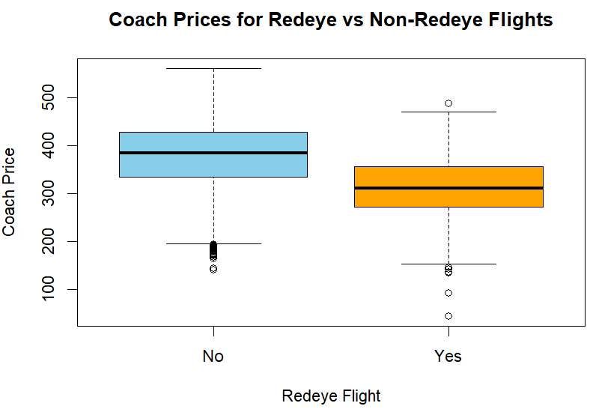
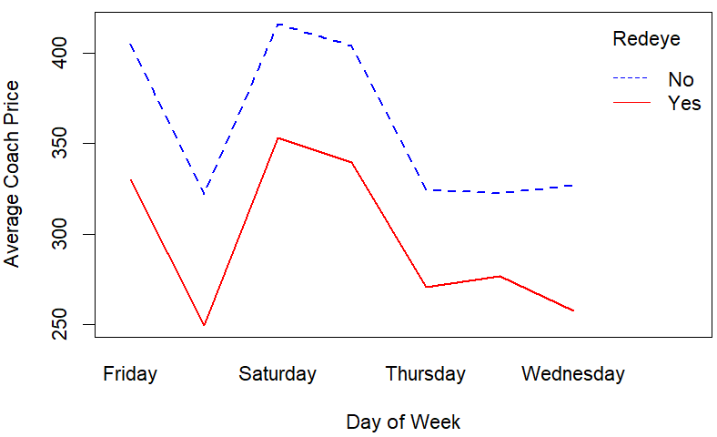

Interpretation: Non-redeye flights generally have higher coach ticket prices than
redeye flights across all days of the week. This suggests that passengers may prefer daytime
flights, increasing their ticket prices.
Among all days, Saturday has the highest average coach ticket prices for both redeye and
non-redeye flights. Redeye flights consistently show lower average prices, indicating they are
usually cheaper options for travelers.

Question:10 Perform the analysis for appropriate variables:
Solution:
R Code:
# Overall Statistical Analysis
# Summary Statistics
summary(flight[, c(
"coach_price",
"firstclass_price",
"miles",
"passengers",
"delay",
"hours"
)])
# Mean
sapply(flight[, c(
"coach_price",
"firstclass_price",
"miles",
"passengers",
"delay",
"hours"
)], mean)
# Median
sapply(flight[, c(
"coach_price",
"firstclass_price",
"miles",
"passengers",
"delay",
"hours"
)], median)
# Standard Deviation
sapply(flight[, c(
"coach_price",
"firstclass_price",
"miles",
"passengers",
"delay",
"hours"
)], sd)
# =====================================
# Histogram of Coach Prices
hist(
flight$coach_price,
col = "skyblue",
border = "black",
main = "Distribution of Coach Ticket Prices",
xlab = "Coach Ticket Price"
)
# =====================================
# Boxplot of Coach Prices
boxplot(
flight$coach_price,
col = "lightgreen",
main = "Boxplot of Coach Ticket Prices",
ylab = "Coach Ticket Price"
)
# =====================================
# Bar Chart of Flights by Day
barplot(
table(flight$day_of_week),
col = "lightgreen",
main = "Flights by Day of Week",
xlab = "Day of Week",
ylab = "Frequency"
)
# =====================================
# Correlation Matrix
cor_matrix <- cor(
flight[, c(
"coach_price",
"firstclass_price",
"miles",
"passengers",
"delay",
"hours"
)],
use = "complete.obs"
)
print(cor_matrix)

# =====================================
# Correlation Heatmap
library(corrplot)
corrplot(
cor_matrix,
method = "color",
addCoef.col = "black",
tl.col = "black",
number.cex = 0.8
)
# =====================================
# Independent t-test
# Weekend vs Weekday Coach Prices
t_test <- t.test(
coach_price ~ weekend,
data = flight
)
print(t_test)
# =====================================
# Linear Regression
# Predict First-Class Price
model_linear <- lm(
firstclass_price ~ coach_price,
data = flight
)
summary(model_linear)
# Regression Equation
coef(model_linear)
# =====================================
# Logistic Regression
# Predict Redeye Flights
flight$redeye_binary <- ifelse(
flight$redeye == "Yes",
1,
0
)
model_logistic <- glm(
redeye_binary ~ coach_price + hours + delay,
data = flight,
family = binomial
)
summary(model_logistic)
Python Code:
#Summary statistics(mean,median,standard deviation)
sample_airline[["miles","passengers","coach_price","firstclass_price"]].agg(["mean","median","std"])
#Visualization using histogram,barplot,boxplot
import matplotlib.pyplot as plt
#Histogram
plt.hist(sample_airline["firstclass_price"],
bins=20,
edgecolor="black")
plt.title("Histogram of First Class Ticket Price",fontsize=16)
plt.xlabel("First Class Price")
plt.ylabel("Frequency")
plt.show()
#Boxplot
plt.boxplot(sample_airline["coach_price"],
patch_artist=True,
boxprops=dict(facecolor="darkgreen",
color="black"))
plt.title("Boxplot of Coach Ticket Price")
plt.ylabel("Coach Price")
plt.show()
#Barplot
#Count flights for each day
day_count=sample_airline["day_of_week"].value_counts()
plt.bar(day_count.index.astype(str),
day_count.values,
color="darkgreen",
edgecolor="black")
plt.title("Barplot Day of Week flights")
plt.xlabel("Day of Week")
plt.ylabel("Number of flights")
plt.show()

Output:
Overall Statistical Analysis:
- Summary Statistics:
Variable | Mean | Median | Standard Deviation
Coach Price | 375.55 | 380.55 | 68.01
First-Class Price | 1453.20 | 1502.13 | 162.94
Miles | 1992.44 | 1980.00 | 931.63
Passengers | 207.63 | 209.00 | 12.95
Delay | 12.84 | 10.00 | 37.18
Hours | 3.61 | 4.00 | 1.72

Variables | Coach Price | First-Class Price | Miles | Passengers | Delay | Hours
Coach Price | 1.00 | 0.76 | 0.33 | 0.18 | 0.00 | 0.33
First-Class Price | 0.76 | 1.00 | 0.27 | 0.03 | 0.00 | 0.27
Miles | 0.33 | 0.27 | 1.00 | -0.01 | 0.01 | 0.98
Passengers | 0.18 | 0.03 | -0.01 | 1.00 | -0.02 | -0.01
Delay | 0.00 | 0.00 | 0.01 | -0.02 | 1.00 | 0.01
Hours | 0.33 | 0.27 | 0.98 | -0.01 | 0.01 | 1.00
- Correlation Matrix:

- Independent t-test (Weekend vs Weekday Coach Prices):
Measure | Value
Mean Coach Price (Weekday) | 320.2735
Mean Coach Price (Weekend) | 405.5754
t-value | -74.816
p-value | < 2.2e-16

- Linear Regression Model:
Regression Equation: $\hat{Y}=766.35723+1.82888X$
where,
- $\hat{Y}$= Predicted First-Class Price
- $X$= Coach Ticket Price
Measure | Value
Intercept | 766.35723
Slope | 1.82888
(R^2) | 0.5828
p-value | < 2.2e-16

- Logistic Regression Model:
Logistic Regression Equation:
$$log⁡\left(\frac{p}{1-p}\right)=1.60799-0.01547(\text{coach_price})+0.23190(\text{hours})+0.00105(\text{delay})$$
where,
- $p$= Probability of a redeye flight
Variable | Estimate | p-value
Intercept | 1.60799 | 5.77e-13
Coach Price | -0.01547 | < 2e-16
Hours | 0.23190 | 2.99e-16
Delay | 0.00105 | 0.159

Interpretation: The average coach ticket price on weekends is significantly higher than
on weekdays. Since the p-value is extremely small, there is a statistically significant
difference between weekday and weekend ticket prices.
There is a strong positive relationship between coach ticket price and first-class ticket price.
About 58.28% of the variation in first-class prices is explained by coach ticket prices.
Longer flights are more likely to be redeye flights, while higher coach ticket prices reduce the
probability of redeye flights. Delay does not have a statistically significant effect on redeye
flight prediction.

